Installing a user-provisioned cluster on bare metal

In OpenShift Container Platform 4.11, you can install a cluster on bare metal infrastructure that you provision. **Internet access for OpenShift Container Platform**

In OpenShift Container Platform 4.11, you require access to the internet to install your cluster.

You must have internet access to:

* Access [OpenShift Cluster Manager Hybrid Cloud Console](https://console.redhat.com/openshift) to download the installation program and perform subscription management. If the cluster has internet access and you do not disable Telemetry, that service automatically entitles your cluster.
* Access [Quay.io](http://quay.io/) to obtain the packages that are required to install your cluster.
* Obtain the packages that are required to perform cluster updates.

### Required machines for cluster installation

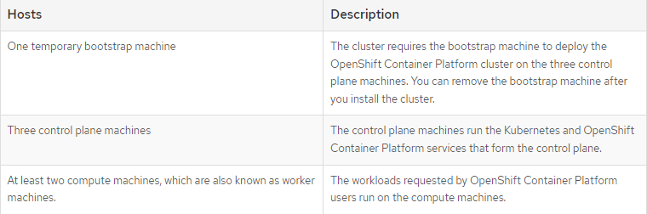

The bootstrap and control plane machines must use Red Hat Enterprise Linux CoreOS (RHCOS) as the operating system. However, the compute machines can choose between Red Hat Enterprise Linux CoreOS (RHCOS), Red Hat Enterprise Linux (RHEL) 8.4,

### Minimum resource requirements for cluster installation

